1. The artwork and design must be original*, and must reflect the Medieval/Renaissance era. The poster should have a clear, concise design with legible text and be eye-catching from a distance, as the winning design may be printed on concession items such as t-shirts.
* Posters may not include artwork based on copyrighted and/or trademarked images. Please do not use images from books, newspapers, magazines, or any Internet sources not in the public domain, as this would not comply with the “original art” rules of the contest. AI-generated artwork will not be considered.
2. The entry must be in a vertical format, 18” x 24.” The following information must be included in the poster design:
a. The Faire’s name: Alabama Renaissance Faire
b. Date of the Faire: October 24-25, 2026
c. The place: Florence, Alabama
d. The web address: www.thealrenfaire.org
3. Important Dates for submission of poster entry:
a. The guidelines will be posted to all media outlets on Tuesday, May 26, 2026.
b. Entries will be due no later than Friday, July 10, 2026.
4. The artist may submit the camera-ready design (600 dpi minimum/1200 preferred) through Google Drive with the link made shareable. Email the shareable Google Drive link to director@thealrenfaire.org. Alternatively, entries may be saved to a flash drive and hand-delivered to the director’s office: Billy Warren, City-County Government Building, 102 South Court Street, 2nd Floor, Florence, AL, 35630, or mailed to Alabama Renaissance Faire, P.O. Box 431, Florence, AL, 35631.
5. A panel of judges will make the final determination of the winning entry based on artistic merit and suitability as a visual image for the Alabama Renaissance Faire.
​
6. A prize of $500 will be paid to the winner upon confirmation from the printer that the design is approved for use on Alabama Renaissance Faire merchandise.
​
7. SPECIAL NOTE: At the discretion of the Board of Directors of the Alabama Renaissance Faire, a non-winning, properly-submitted poster design from a previous year may be updated to reflect the current year’s date and resubmitted in a following year. The entry fee for such resubmission shall be waived and, if selected, the winner will receive the current prize money.

Name: Click or tap here to enter text.
Address: Click or tap here to enter text.
City, State, Zip: Click or tap here to enter text.
Phone: Click or tap here to enter text.

Entry Fee: $10.00 per entry (limit of 2 entries per artist) – use the following link or QR Code
to pay online.

https://app.autobooks.co/pay/the-al-ren-faire-2025
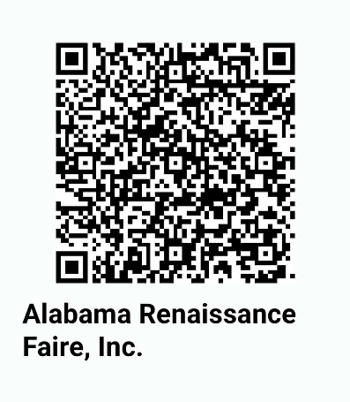
OR: Make check payable to Alabama Renaissance Faire and mail to P.O. Box 431, Florence, AL 35631. Teachers who wish to enter classroom projects may email director@thealrenfaire.org for specific guidelines regarding student work.

STATEMENT OF RIGHTS
The Alabama Renaissance Faire retains the rights to print and/or exhibit all entries. Entries become the property of the Alabama Renaissance Faire.

I have reviewed the rules for the Alabama Renaissance Faire Poster Contest, and I understand them.
Signature: Click or tap here to enter text.
Date: Click or tap to enter a date.

